Machine learning models for drip irrigation optimization and sustainable water management.
Abstract
Traditional drip irrigation systems rely on manual monitoring and management, often leading to either underwatering or overwatering the plant, causing diseases and low crop yields. These limitations contribute to increased costs, and water waste. Moreover, the conventional methods struggle to produce real-time data, making it difficult to control the irrigation timings. To overcome these challenges, smart drip irrigation systems integrate IoT sensors, automation and data-driven decision-making. Precision irrigation utilizes various soil and environmental sensors like soil moisture sensors, pH sensors, salinity sensors, temperature and humidity sensors, to monitor key environmental parameters. A significant advancement in smart irrigation involves use of consumer-grade electronics like microcontrollers(e.g., ESP32, Arduino, Raspberry pi), Wi-Fi/Bluetooth and communication modules, effectively exploiting novel electronics for scalable and cost-effective deployment.This paper suggests using machine learning models(Random Forest, XGBoost, LSTM and e.t.c.) to optimize the irrigation scheduling based on IoT sensor data, including pH level, soil moisture, and salinity, that improve water management, plant health, and overall crop cultivation efficiency.
Keywords
Drip irrigation; Machine learning; Precision farming; Sustainable agriculture; Sustainable water management; IoT sensors; Smart irrigation
1.Introduction
According to FAO, Agriculture accounts for 69% of global water usage. In order to reduce this figure, sustainable irrigation techniques were developed, such as drip irrigation systems. The structure of the drip irrigation system is as follows: pump unit, control head(microcontrollers in smart drip irrigation case), main pipe, sub-main pipe, laterals, emitters and drippers. This method is highly effective for row crops and orchards(fruit trees, including date palms orchards), such as tomatoes, grapes, corn, cauliflower, cabbage and other similar crops. As Jayant et al. (2022) notes, use of drip irrigation is prohibitive for small and medium sized farms due to high initial costs, and its use is dependent on 3 factors: 1.the ease of technology use and economically feasibility 2.awareness of the technology by farmers 3.availability for farmers. Drip irrigation systems produce higher crop yields, better management of water and fertilizers, and lower salinization, labor cost. It also reduces the risk of diseases associated with overly damped soil, and prevents erosion.
Jaiswal et al. (2025) discuss the limitations of traditional drip irrigation, including manual water scheduling and control, lack of adaptability to weather conditions, and low efficiency in heterogeneous soil. Smart drip irrigation systems help to overcome these challenges using IoT sensors and microcontrollers(e.g., ESP 32, Arduino, ESP8266) for automated water scheduling. The author also states that this method extensively relies on the rule-based decisions, based on sensor inputs.
Machine learning algorithms offer considerable advantages over rule-based methods by learning abstract patterns through historical data. Unlike decision making algorithms based on manually entered thresholds, ML models like Random Forest, SVM and LSTM were effective in soil moisture monitoring, classification of water stress and irrigation forecasting using IoT sensors’ data (Oğuztürk, 2025). Empirical evidence shows that implementing AI-driven irrigation systems allows to improve water savings by 30-50%, and increase crop yields by 20-30%, with particularly high results in arid areas where the benefits of precision irrigation are the highest (Oğuztürk, 2025). Furthermore, these adaptive learning approaches enhance over time by training on data produced in real-time.
The integration of the ML-based drip irrigation system directly aligns with United Nations Sustainable Development Goals(SDGs). The paper supports SDG 2 (Zero Hunger) by promoting sustainable irrigation systems and food security through precision monitoring; and SDG 12 (Responsible Consumption and Production) by optimizing water usage and minimizing waste in the irrigation system.
Despite the potential of ML-based smart irrigation systems, several challenges still remain. Most systems focus only on the soil moisture control, and don’t fully use the potential of data collected IoT sensor networks. Additionally, there is a need to compare the effectiveness of different models’ performance. Furthermore, the connection between precision irrigation and actual achievement of SDG goals needs to be investigated empirically.
The objectives of the paper the following:
1.Compare the performance of different machine learning algorithms(Random Forest, LSTM, SVM,ANN) in predicting irrigation timing
2.Increase the water savings and agricultural productivity through ML-based irrigation systems compared to traditional scheduling methods.
3.Prove the alignment of smart precision irrigation with the UN’s Sustainable Development Goals.
The research paper is answering the following question: Can a multi-sensor IoT framework integrating soil moisture, electrical conductivity, pH, CO₂, temperature, and humidity, assisted with ML models (Random Forest, XGBoost, LSTM, SVM), outperform both single-sensor approaches and conventional rule-based irrigation scheduling in terms of water use efficiency and crop health outcomes, and to what extent does this approach empirically fufill SDG 2 and 12?
The organization of the paper is as follows: Section 2 reviews related work on smart drip irrigation systems, IoT sensor networks, and ML models application. Section 3 describes the methodology, focusing on the ML development part of the framework. Section 4 presents ML metrics and patterns in the data, and discusses the alignment with SDG goals. Section 5 concludes with key findings and directions for future research.
2.Literature Review
Pereira et al. (2023) created an IoT enabled smart drip irrigation system using ESP32 microcontroller. Sensors used are SEN0308 DFRRobot(soil moisture), DS18B20(temperature sensor), DHT22(air humidity sensor), FS300A(water flow sensor).The microcontroller opened the solenoid valve if the temperature was 27-32°C and humidity range was between 25-90%, and dry, which is when the moisture reading from the sensor is above 380. There were two watering intervals: from 5 to 8 am and 6-8 pm. The water flow sensor was used to measure the water flow and to ensure that if the soil moisture sensor didn’t change its readings, and the valve was already open the same day, then the valve will not be opened a second time, to prevent over-watering the soil.
Belli et al. (2025) developed a LoRaWAN-enabled IoT infrastructure to monitor tomato cultivation(Solanum lycopersicum L. cv. HEINZ 1301) under three distinct irrigation conditions in cultivation in Parma, Italy. The system used a Milesight UG67 outdoor gateway, sensors like Milesight EM500 C02 for humidity, temperature, and CO2, 3 Talkpool OY1310 water meters, 3 Milesight EM500 SMTC soil sensors to measure electrical conductivity, moisture and temperature at 20 cm depth. From the beginning of the blooming phase, the farmer applied 100% (line #1), 60% (line #2) and 30% (line #3) of the amount of water recommended by the Irriframe service. Data was collected from June 29th to September 13, 2023, with a 10 minute interval, and processed via “The Things Network” and the “Agriware” platform to calculate daily agronomic metrics like Growing Degree Days(GDD) and various Heat Units. The authors mention that the 10-minute sampling interval was a necessary trade-off between monitoring accuracy and device battery preservation.
Jaiswal et al. (2025) reviewed the current methods and architectures, suggesting that lightweight ML models(KNN, RF, NB, SVM) are computationally efficient, running locally on microcontroller with accuracy about 95-98% across different studies, consuming less energy compared to DL models(CNN,LSTM, Reinforcement Learning), which eliminates the need for edge-cloud computing. Moreover, if deployed locally, ML models ensure nearly instant predictions (<1s), with microcontrollers regulating water pumps and solenoid valves based on the prediction. The author underscores limitations of the IoT drip irrigation systems, such as high initial cost, unstable connectivity issues in rural areas, and overreliance of solar-powered systems on local climate. Federative learning is suggested as a solution for the problem of scalability and concerns of data privacy across regions.
Vianny et al. (2022) used KNN, GBT and LSTM models to predict and forecast the requirement of irrigation using various parameters. KNN for parameters collection using IoT sensors, LSTM and GBT were used in a combination to forecast water demand across multiple horizons. As a result, water usage per banana tree or node was reduced by 33.14% in 2020, and about 50.1% in 2021.
Priya et al. (2024) trained SVM, DT, RF, NB models on 70% and tested on 30% of the dataset with 3587 records. The dataset had a time-stamp feature, 4 features produced by sensors and one target feature(Pump operation On/Off). The features produced by the sensors were temperature, humidity, soil moisture and water level in the soil. The SVM model achieved top accuracy of 95.86%, DT got 90.12%, followed by RF’s 90% and ending with NB’s lowest score of 87.63%. The study considered wireless transmission of data, firstly being sent to the microcontroller, simply processed, and then sent to the cloud storage through Wi-Fi link, with low latency.
The soil moisture, temperature/humidity and rain sensors were connected to the Arduino board, and months of data was grouped and transmitted to Node-Red and MongoDB(Tace et al., 2022) .Local MongoDB provides data for training multiple prediction models, and a cloud MongoDB to receive, visualize data, and give a prediction. The author got KNN model with highest accuracy of 98.3%, Sequential Neural Network with an accuracy of 97.2%, NB with 97.0%, SVM with 96.7% and Logistic Regression with 96.2% accuracy.
Oğuztürk et al. (2025) used an autonomous irrigation system that integrated IoT sensors and AI. Sensors used are DHT11 for both temperature and humidity, controlled by an Arduino MEGA microcontroller. The LSTM model was chosen due to its capability to handle sequential data and capture temporal dependencies, maintaining accuracy over long time intervals. The LSTM model was provided with soil moisture content, pH levels, temperature, relative humidity, light intensity, encoded plant name data and outputs the predicted watering volumes and schedules. AI-supported irrigation led to reduction of overall average water use by 87.98%.The study showed that manual irrigation had irregular patterns in growth of the plants and frequently caused plant desiccation. Using the ANOVA test, it was concluded that plant height for AI-supported irrigation was statistically significantly higher compared to manual irrigation. It was recommended that future studies should be conducted in the field on a large scale with heterogeneous soil and account for the soil health parameters.
Tace et al. (2023) has used K-NN, NB and SVM to solve the classification task of predicting whether the pump should be off or on. K-NN algorithm showed the best performance, 98.4% accuracy. In the study, collected data from sensors (temperature, air humidity and soil moisture) were passed from the Arduino card to the Node-RED platform to store, visualize, monitor and analyze the collected data. Later, the ML models were used for predictions.
Khan and Sharma (2025) uses a DL framework with multimodal data. For example, high-resolution satellite images are fed into CNNs to monitor crop health and anomalies, and temporal data and soil moisture levels are used by LSTMs to extract seasonal patterns and trends, where both models continuously change parameters, based on new data. As a result, the LSTM showed 85% precision, 78% recall, 81% F1-Score, which is a better result compared to RF, GBM, and SVM. The author highlights the essence of recall, because it is crucial in climate prediction scenarios.

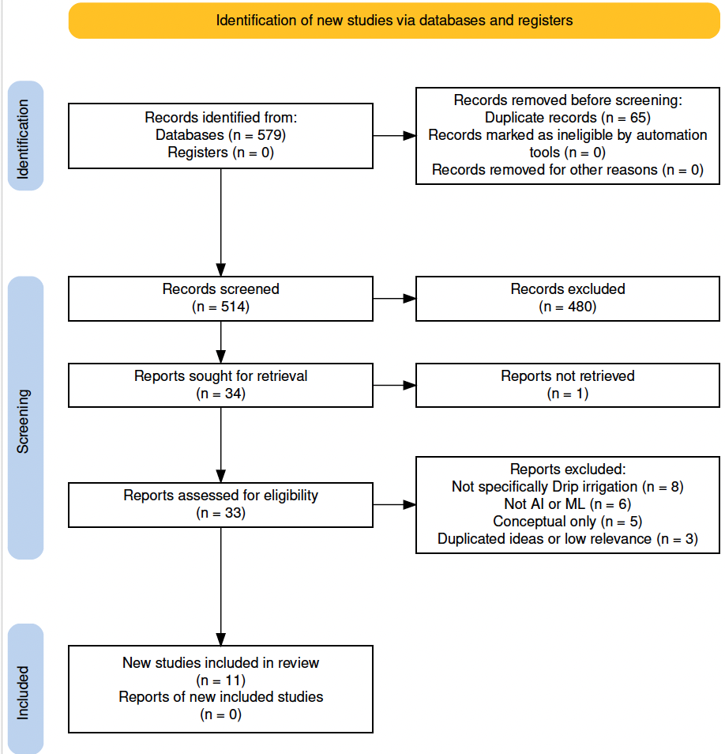
Fig. 1. PRISMA 2020 flow diagram of study selection process (generated using the PRISMA 2020 Flow Diagram tool; Haddaway et al., 2022).
Fig. 1 presents the PRISMA flowchart highlighting the reference selection process. The selection was performed by using databases such as ScienceDirect, Google Scholar and the library database of University of Doha for Science and Technology. Titles including “Smart Drip Irrigation Systems” and “IoT sensors” and “AI or ML or DL”. The selection criteria focuses on peer-reviewed studies dealing with smart drip irrigation systems with ML models with quantitative data, while exclusion criteria removed studies with insufficient data or quality. Titles, abstracts and full texts were assessed in this order, and the PRISMA flowchart outlines the identification, screening and inclusion stages.

3.Methodology
Smart Drip irrigation systems usually have the following framework Fig. 2: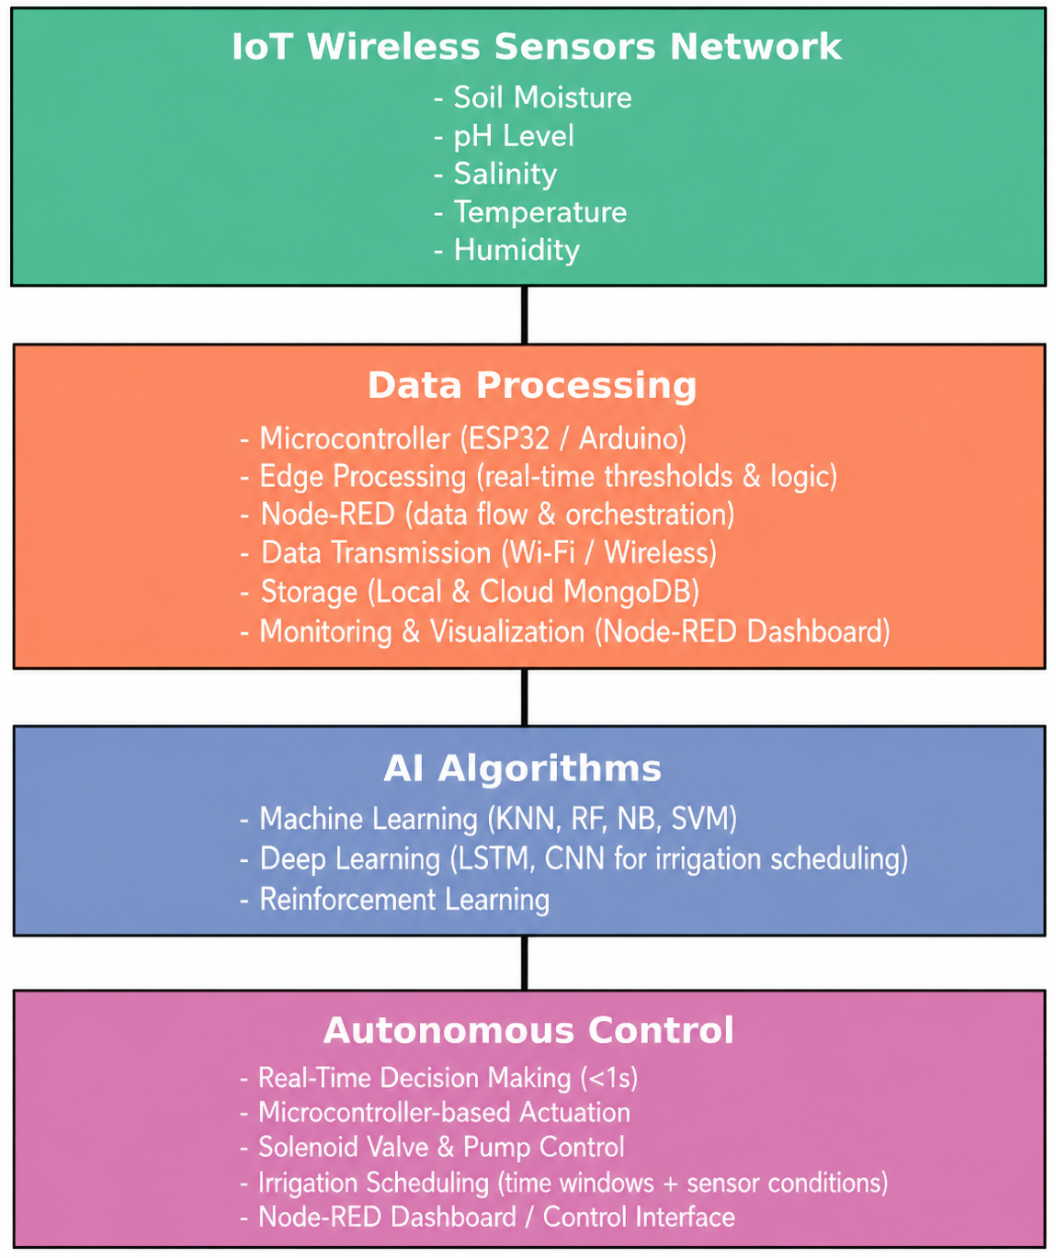
Light-weight ML models for managing smart drip irrigation systems.
4.Results and Discussion
I will show some metrics like precision, recall, F1, accuracy. Will show the graph of feature importances, and comparison of models’ metrics.
5.Conclusion
The results of this and previous studies highlight the importance of AI-driven irrigation systems for developing water sustainability policies in regions with water scarcity. Policymakers should enhance their adoption on both local and national levels and develop regulatory frameworks to support integration into sustainable agriculture, alongside promoting collaboration between research institutions, government and industry (Oğuztürk et al., 2025).
Abbreviations
The following abbreviations are used in the manuscript:
DL - Deep Learning
IoT - Internet of Things
KNN - K-Nearest Neighbours
SVM - Support Vector Machine
ANN - Artificial Neural Network
CNN - Convolutional Neural Network
LSTM - Long Short-Term Memory
GBT - Gradient Boosted Tree
GBM - Gradient Boosting Machine
Data availability
Data is available upon the request.
References
- Jayant, B., Dahiya, K., Rukhiyar, A., Raj, R., & Meena, R. K. (2022). A review of the drip irrigation system. Journal of Engineering Research and Application, 1. https://www.researchgate.net/profile/Rahul-Meena-11/publication/360442883_A_REVIEW_OF_THE_DRIP_IRRIGATION_SYSTEM/links/6278f5543a23744a726f91ac/A-REVIEW-OF-THE-DRIP-IRRIGATION-SYSTEM.pdf
- Jaiswal, N., Kumar, T. V., & Shukla, C. (2025). Smart drip irrigation systems using IoT: A review of architectures, machine learning models, and emerging trends. Discover Agriculture, 3, 253. https://doi.org/10.1007/s44279-025-00430-1
- Oğuztürk, G. E. (2025). AI-driven irrigation systems for sustainable water management: A systematic review and meta-analytical insights. Smart Agricultural Technology, 11, 100982. https://doi.org/10.1016/j.atech.2025.100982
- Atapattu, A. J., Ranasinghe, C. S., Nuwarapaksha, T. D., Udumann, S. S., & Dissanayaka, N. S. (2024). Sustainable agriculture and sustainable development goals (SDGs). In Emerging technologies and marketing strategies for sustainable agriculture (pp. 1–27). IGI Global. https://doi.org/10.4018/979-8-3693-4864-2.ch001
- Vianny, D. M. M., John, A., Mohan, S. K., Sarlan, A., Adimoolam, & Ahmadian, A. (2022). Water optimization technique for precision irrigation system using IoT and machine learning. Sustainable Energy Technologies and Assessments, 52(Part D), 102307. https://doi.org/10.1016/j.seta.2022.102307
- Pereira, G. P., Chaari, M. Z., & Daroge, F. (2023). IoT-enabled smart drip irrigation system using ESP32. IoT, 4(3), 221–243. https://doi.org/10.3390/iot4030012
- Priya, N. M., Amudha, G., Dhurgadevi, M., Malathi, N., Balakrishnan, K., & Preetha, M. (2024). IoT and machine learning based precision agriculture through the integration of wireless sensor networks. Journal of Electrical Systems, 20(4s). https://doi.org/10.52783/jes.2399
- Tace, Y., Tabaa, M., Elfilali, S., Leghris, C., Bensag, H., & Renault, E. (2022). Smart irrigation system based on IoT and machine learning. Energy Reports, 8, 1025–1036. https://doi.org/10.1016/j.egyr.2022.07.088
- Ercan Oğuztürk, G., Murat, C., Yurtseven, M., & Oğuztürk, T. (2025). The Effects of AI-Supported Autonomous Irrigation Systems on Water Efficiency and Plant Quality: A Case Study of Geranium psilostemon Ledeb. Plants, 14(5), 770. https://doi.org/10.3390/plants14050770
- Tace, Y., Elfilali, S., Tabaa, M., & Leghris, C. (2023). Implementation of smart irrigation using IoT and artificial intelligence. Mathematical Modeling and Computing, 10(2), 575–582. https://doi.org/10.23939/mmc2023.02.575
- Khan, R., & Sharma, P. (2025). AI-enabled smart irrigation for climate-resilient agriculture. SHS Web of Conferences, 216, Article 01005. https://doi.org/10.1051/shsconf/202521601005
- Haddaway, N. R., Page, M. J., Pritchard, C. C., & McGuinness, L. A. (2022). PRISMA2020: An R package and Shiny app for producing PRISMA 2020-compliant flow diagrams, with interactivity for optimised digital transparency and Open Synthesis. Campbell Systematic Reviews, 18, e1230. https://doi.org/10.1002/cl2.1230
- Page, M. J., McKenzie, J. E., Bossuyt, P. M., Boutron, I., Hoffmann, T. C., Mulrow, C. D., et al. (2021). The PRISMA 2020 statement: An updated guideline for reporting systematic reviews. BMJ, 372, n71. https://doi.org/10.1136/bmj.n71

